UNIVERSITY OF AZAD JAMMU &
KASHMIR
Department of CS & IT

Project Title: Student Report
Card System
Group G :

Submit By:
Ayesha Abdul Aziz. Roll No:67
Mowaddat Zahra. Roll No: 99
Hamid Haroon. Roll No:87
Juraij Sadaqat Roll No: 97

Submitted To: [Dr Wajid Aziz]
.

Introduction
This project is a Student Report Card System developed using the C++ programming language. It follows a procedural programming approach and provides a menu-driven interface to manage student academic records. File handling is used to ensure permanent data storage.

Objectives
- To store and manage student records digitally
- To reduce manual record keeping
- To demonstrate core C++ programming concepts

Description of the System
The system stores roll number, name, and marks using arrays. Users can add, view, edit, and delete records through a menu-driven interface. All data is saved in a text file for future use.

Programming Approach
The project is implemented using a procedural programming approach. Functions, arrays, loops, conditional statements, and file handling are used.
5. Program Logic (Pseudocode)

START
Load data from file
Display Menu
Take user choice
Perform selected operation
Save data to file
Repeat until Exit
END

06.IPO CHART
Inputs | Process |  | Output
1. Add Students :
Roll No (integer),  Name (string),  Marks (float) | 1. Check if database is full (total ≥ SIZE)  2. Validate marks (0 ≤ marks ≤ 1100)  3. Add student to database (rollNos, names, marks arrays) |  | Student Records (rollNo, name, marks, percentage)  or  No Records!
2. Show Students :
None | 1. Check if records exist (total > 0)  2. Display student records (rollNo, name, marks, percentage) |  | Student Records (rollNo, name, marks, percentage)  or  No Records!
3. Edit Student :
Roll No (integer),  New Roll No (integer),  New Name (string),  New Marks (float). | 1. Search for student (rollNo)  2.if found then update it  3. Validate new marks (0 ≤ marks ≤ 1100)  4.Update student details (rollNos, names, marks arrays) . |  | Record Updated!  or  Student Not Found!
4. Delete Student :
Roll No (integer). | 1. Search for student (rollNo)  2. Delete student from database (rollNos, names, marks arrays). |  | Student Deleted!  or  Student Not Found!
5. Exist:
None | 1. Display "Exist program!" message.  2. Exit the program or loop. | Exist program!
6. Main Menu:
Choice (1-5) | 1. Display menu.  2. Perform action based on choice (add/ show/ edit/ delete/ exit) | Perform Action  or  Exist program!

7. Functions Used in the Program

1: addStudent()
This function is used to add a new student record. It takes roll number, name, and marks as input. Marks are validated to ensure they are between 0 and 1100.

2: showStudents()
This function displays all student records. It also calculates and displays the percentage of each student.

3: editStudent()
This function allows the user to edit an existing student record by entering the roll number.

4: deleteStudent()
This function deletes a student record based on the roll number and shifts remaining records.

5: main()
The main function displays a menu with options:
- Add Student
- Show Students
- Edit Student
- Delete Student
- Exit

08.Flowchart

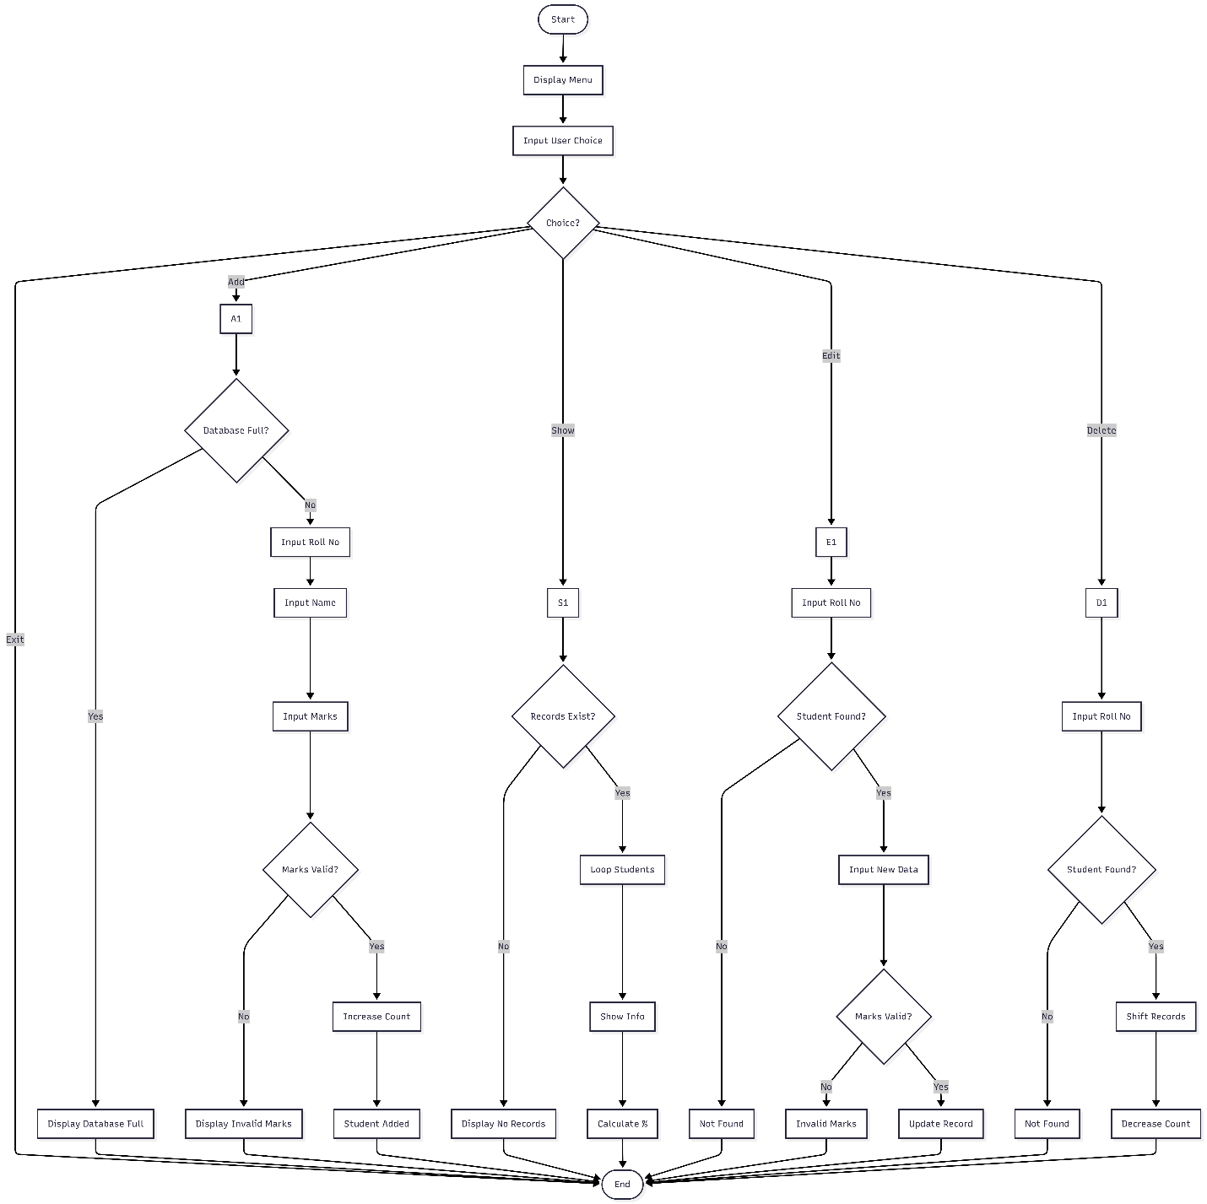

09.Program
#include <iostream>
#include <fstream>
#include <string>
using namespace std;

const int SIZE = 100;
int rollNos[SIZE];
string names[SIZE];
float marks[SIZE];
int total = 0;
const string FILE_NAME = "students.txt";

// Load data from file
void loadData() {
ifstream file(FILE_NAME);
if (!file) return;
while (file >> rollNos[total] && total < SIZE) {
file.ignore(); // Ignore newline
getline(file, names[total]);
file >> marks[total];
total++;
}
file.close();
}

// Save data to file
void saveData() {
ofstream file(FILE_NAME);
for (int i = 0; i < total; i++) {
file << rollNos[i] << endl;
file << names[i] << endl;
file << marks[i] << endl;
}
file.close();
}

// Function to Add Students:
void addStudent() {
if (total >= SIZE) {
cout << "Database Full!\n";
return;
}
cout << "Enter Roll No: ";
cin >> rollNos[total];
cout << "Enter Name: ";
cin.ignore();
getline(cin, names[total]);
while (true) {
cout << "Enter Marks Out Of 1100: ";
cin >> marks[total];
if (marks[total] >= 0 && marks[total] <= 1100) {
break;
} else {
cout << "Invalid marks! Please enter marks between 0 and 1100.\n";
}
}
total++;
saveData(); // Save after adding
cout << "Student Added!\n";
}

// Function to Show Students:
void showStudents() {
if (total == 0) {
cout << "No records!\n";
return;
}
for (int i = 0; i < total; i++) {
float percentage = (marks[i] / 1100) * 100;
cout << "\nRoll No: " << rollNos[i];
cout << "\nName: " << names[i];
cout << "\nTotal Marks: 1100";
cout << "\nMarks Obtained: " << marks[i];
cout << "\nPercentage: " << percentage << "%\n";
}
}

// Function to Edit students:
void editStudent() {
int r;
cout << "Enter Roll No to Edit: ";
cin >> r;
for (int i = 0; i < total; i++) {
if (rollNos[i] == r) {
cout << "Enter New Roll No: ";
cin >> rollNos[i];
cout << "Enter New Name: ";
cin.ignore();
getline(cin, names[i]);
while (true) {
cout << "Enter New Marks: ";
cin >> marks[i];
if (marks[i] >= 0 && marks[i] <= 1100) {
break;
} else {
cout << "Invalid marks! Please enter marks between 0 and 1100.\n";
}
}
saveData(); // Save after editing
cout << "Record Updated!\n";
return;
}
}
cout << "Student Not Found!\n";
}

// Function to delete students:
void deleteStudent() {
int r;
cout << "Enter Roll No to Delete: ";
cin >> r;
for (int i = 0; i < total; i++) {
if (rollNos[i] == r) {
for (int j = i; j < total - 1; j++) {
rollNos[j] = rollNos[j + 1];
names[j] = names[j + 1];
marks[j] = marks[j + 1];
}
total--;
saveData(); // Save after deleting
cout << "Student Deleted!\n";
return;
}
}
cout << "Student Not Found!\n";
}

int main() {
loadData(); // Load data on startup
int choice;
do {
cout<<endl;
cout<<" STUDENT REPORT CARD SYSTEM"<<endl;
cout << "\n1. Add\n2. Show\n3. Edit\n4. Delete\n5. Exit\nChoice: ";
cin >> choice;
if (choice == 1) addStudent();
else if (choice == 2) showStudents();
else if (choice == 3) editStudent();
else if (choice == 4) deleteStudent();
else if (choice == 5) cout << "Exit Program!\n";
else cout << "Invalid choice!\n";
} while (choice != 5);
return 0;
}

Output:
Add Student:
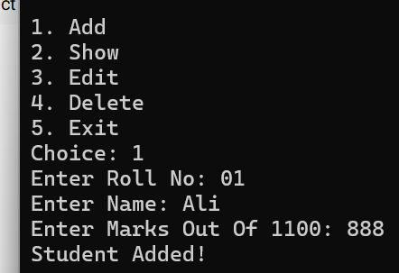
Show
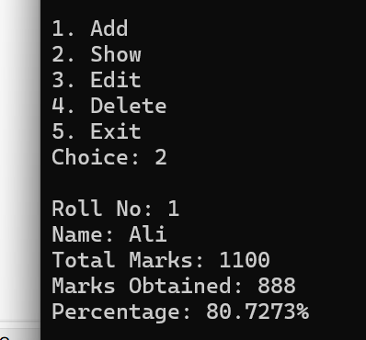

Edit
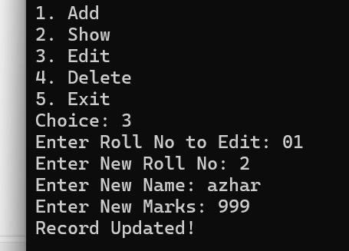
Delete
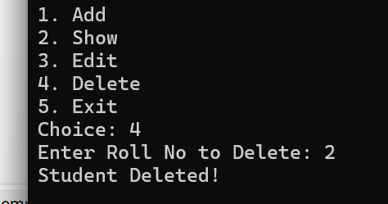
Exist
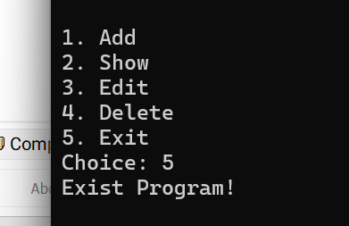

10: Output Description
The program displays confirmation messages such as:
- Student Added
- Record Updated
- Student Deleted
- Student Not Found
It also displays student details including roll number, name, marks, and percentage.

11.Advantages
- Easy to use
- Beginner friendly
- Permanent data storage
- Efficient record handling

12.Limitations
- Console-based system
- Fixed-size arrays
- No graphical interface

13.Conclusion
The Student Report Card System is a reliable procedural C++ application that demonstrates fundamental programming concepts and is suitable for academic submission.

